ELEG 312 - Example Problems Appendix F

**Exercise F.1**

Find the voltage transfer function for the STC network shown in Fig. EF.1.

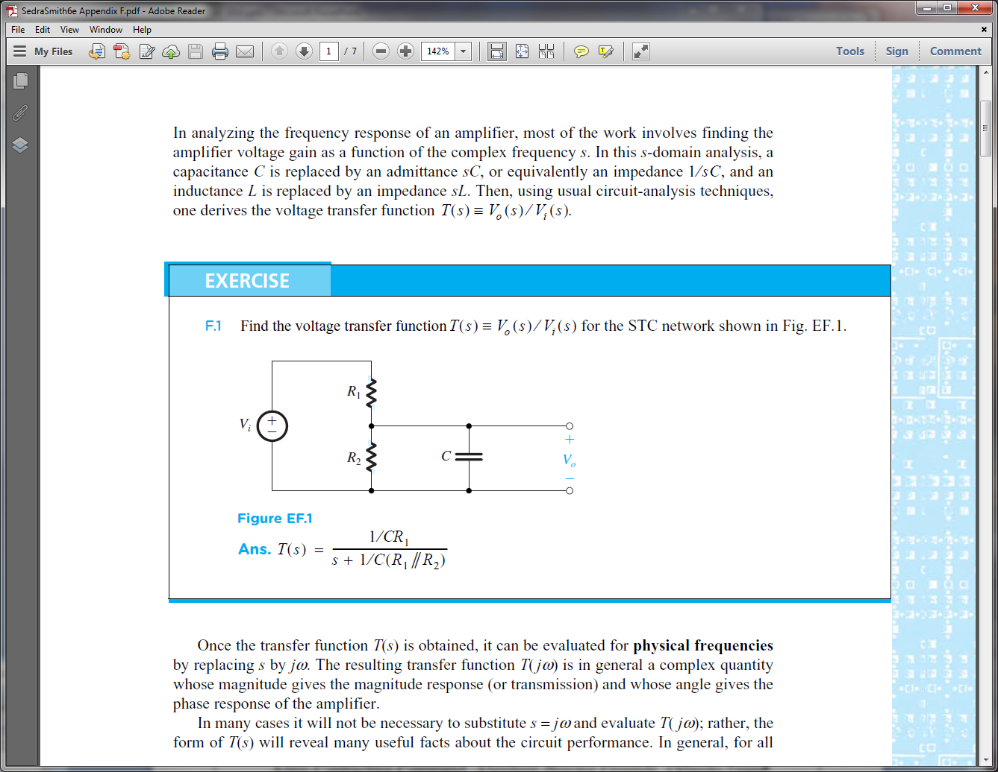

**Example F.1**

An amplifier has the voltage transfer function . Find the poles and zeros and sketch the magnitude of the gain versus frequency. Find approximate values for the gain at ω = 10, 103, and 106 rad/s.

Poles:

Zeros:



**Example F2**

Find the Bode plot for the phase of the transfer function of the amplifier considered in Example F.1.



**Practice Problem I.** A circuit has the following transfer function:



Answer the following

Zeroes: __________________________________

Poles: _________________________________

Draw the magnitude response of the circuit as a function of ** in a Bode plot.

